

Student Government Association
Application 2026-2027

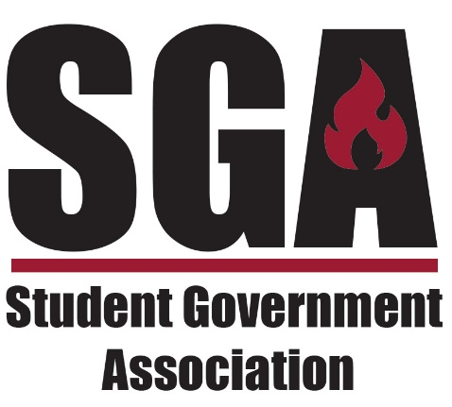

Purpose
Established in 1967, the Student Government Association (SGA) serves as the official governing body for RichmondCC students, helping implement college policies and representing the institution within the community.
Every student is automatically a member and is encouraged to participate in campus events or help shape college policy. Beyond being a platform for student voices, the SGA offers a practical educational environment to develop leadership and management skills. Additionally, scholarships are available for all
serving officers.
Mission
Richmond Community College’s mission is to offer educational opportunities, cultural enrichment, and workforce development and training that will enhance the quality of students’ lives and support economic development in Richmond and Scotland counties.
The mission of the RichmondCC Student Government Association is to enhance the student experience, advocate for the collective needs of the student body, and cultivate a social, inclusive, and professional environment that supports student success

Richmond Community College
Student Government Association (SGA)
Application for Executive Office
Purpose:
The SGA of Richmond Community College serves as the official organization conducting the affairs of its members, providing forums for student development, and acting as a direct liaison to the college administration (p. 1).

PART I: CANDIDATE INFORMATION
Position (Circle One): President | Vice President | Public Information Officer | Secretary
- Name: ____________________________________
- Student ID: ____________________
- Student Email: _____________________________________
- Address: ____________________________________________________________________
- City/State/Zip: ______________________________________________________________
- Phone (Cell): _________________ (Home): _________________
- Program of Study: ________________________
Cumulative GPA: _________________
- Enrollment Status (Circle One): Full-Time | Part-Time
- Advisor:

PART II: CANDIDACY CRITERIA
- Enrollment: Must be currently enrolled at RCC with a minimum
2.5 cumulative GPA
- Presidential Requirements: Must have completed 12+ credit hours and be 18 years of age
- Conduct: No student on probation for violation of the Student Code of Conduct is eligible
- Packet Checklist:
  - Completed Application
  - Letter of Intent (minimum 250 words)

PART III: STATEMENT OF INTENT
- Why do you want to join the SGA Executive Committee?
- What specific experiences, involvement, or skills (leadership, professional, personal) do you bring to this role?
- What is one thing (or what are some goals) you would like to accomplish if elected?
- What is your plan for improving student experience for your community college?

PART IV: SIGNATURE & OFFICIAL INTENT
I, _____________________________________, hereby announce my intentions to run for office within the Student Government Association at Richmond Community College. I realize that this office requires a significant commitment of time and energy
Name:___________________________________ Date: _______________
Signature: ____________________________________ Date: _______________

Responsibilities of the Student Government Officers:
The PRESIDENT of the Student Government Association shall:
- Act as chief officer of the SGA and make recommendations to the administration of the College concerning matters affecting the student body.
- Serve as a non-voting member of the RichmondCC Board of Trustees.
- Attend RichmondCC Disciplinary Hearing committee meetings
- Chair all meetings of the student government council in an efficient and orderly manner, following the most recent edition of Robert’s Rules of Order.
- Preside over all SGA meetings in a non-voting capacity, with the sole exception of casting their vote to break a tie.
- Nominate, with a majority vote of the Executive Board and consent of the SGA advisor, a person to fill the unexpired term of an elected officer should an officer resign or be removed from their position or to fill a position that needs to be filled.
- Have the power to call a special or emergency meeting of the executive board.
- Implement all decisions of the Council.
- Exercise the powers of the SGA Vice President if and when the Vice President is unable.
- Represent the SGA in relations with the administration and with students of other academic institutions when called upon.
- Sign necessary documents, motions, or other measures approved by the Council.
- Represent the students of RichmondCC at official college functions.
- Represent RichmondCC at public and private activities when called upon by the administration.
- Demonstrate good written and oral communication skills.
- Collaborate with the Secretary to develop and distribute the agenda for each meeting.

The VICE PRESIDENT of the Student Government Association shall:
- Exercise the powers of the SGA President when the President is absent or unable to do so.
- Succeed to the office of the President if the President, for any reason, cannot complete their term in the office. The Vice President shall relinquish the office of Vice President to assume the office of President.
- Serve as a voting member of the SGA and an ex officio, non-voting member of the Foundation Board of Directors.
- Attend all official SGA meetings and Executive Board meetings.
- Become knowledgeable of the SGA constitution and Robert’s Rules of Order.
- Represent RichmondCC at public and private activities when called upon by the administration.
- Demonstrate good written and oral communication skills.
- Assist, in reasonable capacities, the SGA President in the execution of all actions taken by the SGA Council.

The SECRETARY shall:
- Be responsible for establishing and maintaining all records and files that pertain to the SGA.
- Keep minutes of all SGA Executive and Council student body meetings; assist in the dissemination of information relevant to the SGA and its meetings as needed.
- Keep an accurate record of attendance at all SGA Executive and Council meetings.
- Prepare the meeting schedule approved by the Council for publication and present the schedule to the SGA advisor(s) for approval.
- Serve as a voting member of the SGA.
- Represent RichmondCC at public and private activities when called upon by the administration.
- Demonstrate good written and oral communication skills.
- Demonstrate good written and oral communication skills.

The Public Information Officer of the Student Government Association shall:
- Oversee all physical bulletin boards and digital "Bright signs" for SGA and Student Life.
- Market events and meetings through social media, digital monitors, and campus-wide flyers.
- Design all promotional materials and event flyers from scratch.
- Maintain a complete photographic archive of all SGA-sponsored activities.
- Direct all meetings using Robert’s Rules of Order and the SGA Constitution.
- Educate the Council on correct parliamentary procedures.
- Sign and archive all official motions passed by the Council.
- Serve as a voting member and act as an official college ambassador at public events.
- Exhibit professional written and oral communication skills at all times.
- and revise meeting rules and SGA documents to reflect current student needs.
- Execute additional tasks as assigned by the SGA President

The Delegates of the Student Government Association shall:
- Represent your academic area and students.
- Connect peers to the broader RichmondCC community.
- Publicize SGA events within your specific area.
- Liaise between your department/campus and the SGA.
- Communicate student needs to the SGA President.
- Report on activities at general meetings.
- Attend leadership workshops and conferences.
- Participate in and promote all SGA functions

